Group Project - Mockups

Advanced Web ProgrammingCOMP1230

Maxim Bondarenko

Malik Iavari

2016

## Project Mock-Ups

### Main Page – User not logged in

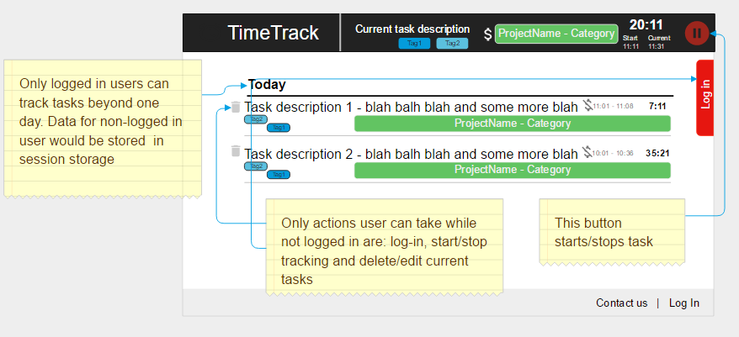

All edits of the tasks will be done in page, effectively it will be a number of forms that can be edited when user double clicks on any element of a form. Form is submitted on person leaving form element or hitting “Enter” button via AJAX so the page does not reload.

### Main Page – User log in/registration

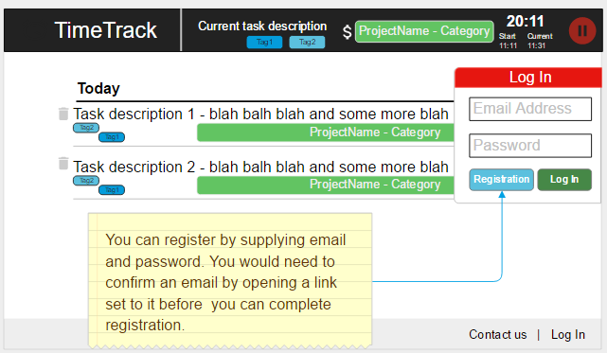

User can login or register via a login form. All data is submitted via AJAX and once validated user will see a success or error message displayed by in-browser capabilities (via JavaScritpt)

### Main Page – User logged in

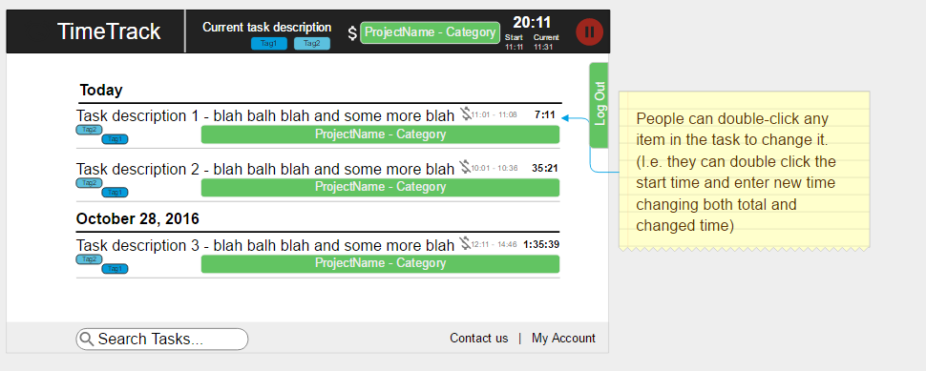

### Report Page

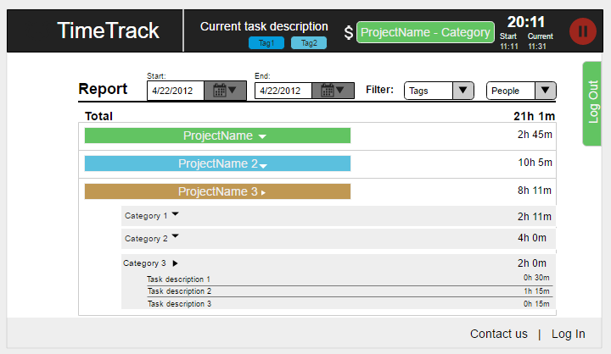

User can see the report for specified timeframe (with start not being latter than end). User can also filter report by people involved and tags attached. He/she can also expand projects and project categories to see detailed time allocation.

### Manage Projects Page

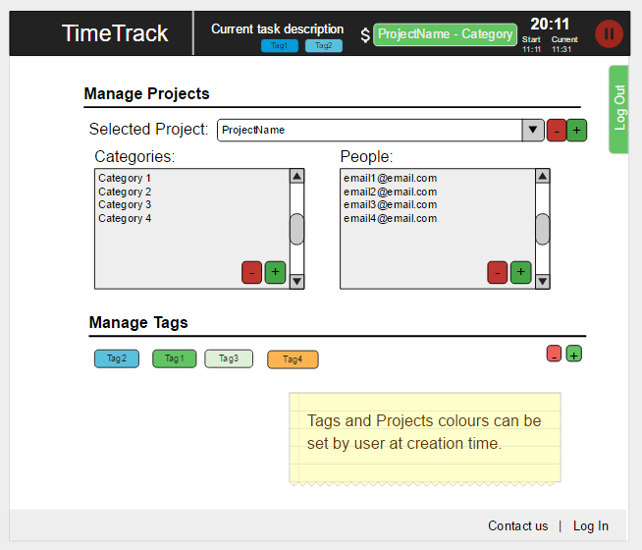

Here people can add/remove projects and add categories(freeform) as well as people(email has to be a valid email registered in the system) to a project. User can also add tags(freeform) – tags can be associated with multiple projects.